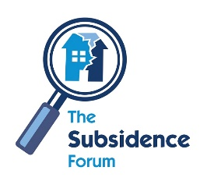
Subs Forum Training Day
Wednesday 17 October 2018
Tewin Bury Farm Hotel, Hertford Road, Welwyn, AL6 0JB
Demonstration Form
Please complete the below form and return to emma.simmonds@agmhouse.com

Name: Company:
Email:

Demonstration Area
Please tick the chosen demonstration area

Soil Investigation

Drainage Survey
Aboricultural reports
Other (please specify)

By demonstrating at this event, you will be volunteering your own resources and time
To ensure all members are given an equal opportunity to participate, completing this form does not guarantee your place to demonstrate. A confirmation email will be sent accepting your demonstration request should you be successful.

The Subsidence Forum, Kinsley House, Ganders Business Park, Kingsley, Bordon, Hampshire, GU35 9LU
Telephone: 01420 471623 www.subsidenceforum.org.uk

